Networking

Introduction
What’s a Network? 🌐
Imagine a network is like a road system for information. Just as roads connect cities, houses, and shops, a network connects devices (like phones, laptops, and servers) so they can "talk" to each other and share stuff.

Simple Analogy 🚗
Think of data as cars:
- Wi-Fi/Cables = Roads.
- Routers = Traffic signs that direct cars (data) to the right place.
- Internet = A giant global highway connecting billions of roads (networks).
Without roads, cars can’t move. Without networks, your Instagram photo or WhatsApp message can’t reach your friend!

Real-Life Examples 🔌
- Home Wi-Fi: Connects your phone, TV, and laptop so you can stream Netflix on the couch.
- School Network: Lets students share files or print homework from any classroom computer.
- The Internet: The biggest network ever—linking your phone in Cairo to a server in California!

Definition

Simple definition
A network is a structured system of interconnected devices (e.g., computers, servers, routers) that communicate wia stadardized rules (protocols) to share resources, exchange data. It relies on physical infrastracture (cables , fiber optics, wireless signals).

Examples
For Small Buisnesses : imagine a coffe shop using a network to connect its cash register, inventory system, and WI-FI for customers. Without-it, orders couldn’t be tracked.
For Big Companies: Think of a hospital where doctors in different departments instantly access patient records, scan result, and schedule surgeries – all because their devices are linked through a secure network .

Why network is imporant
We goona make the importance of the network under light in the two next reel scenarios

Real-Life Scenario: The Day the Network Died at "QuickMart" 🛒
Imagine "QuickMart," a busy grocery store. Everything runs smoothly thanks to its network—until one morning, the network crashes. Here’s what happens:

Role of the Network
- Checkout Chaos:
  - With Network: Cashiers scan items, prices auto-update, and payments process instantly.
  - Without Network: Registers freeze. Cashiers manually look up prices, payments are cash-only, and lines snake out the door.
- Inventory Meltdown:
  - With Network: Sensors track stock in real-time. The system auto-orders milk when shelves are empty.
  - Without Network: Staff can’t see what’s in stock. Shelves stay empty, and angry customers leave.
- Online Orders Collapse:
  - With Network: Delivery apps send orders straight to the kitchen. Drivers pick up groceries in minutes.
  - Without Network: Online orders vanish. Delivery drivers sit idle, and customers demand refunds.
Why This Matters
In just one hour without a network:
- Sales drop by 60%.
- Customer complaints triple.
- Employees panic, scrambling with pen and paper.
By lunchtime, the store manager is sweating, the staff is overwhelmed, and customers are tweeting angrily.
بحلول وقت الغداء، يكون مدير المتجر متعرقًا، والموظفون منهكون، والعملاء يغردون بغضب.

The Bigger Picture
Networks aren’t just about "tech stuff"—they’re the silent heroes of modern life. They:
- Keep businesses alive (no network = no sales).
- Save time (imagine manually tracking 10,000 products!).
- Connect people (your food delivery, mom’s credit card payment, a student’s Zoom class).

Conclusion
Networks are like oxygen—you don’t notice them until they’re gone. Whether it’s a store, hospital, or your phone’s WhatsApp, networks keep the world running smoothly. Without them, chaos reigns الفوضى تسود . That’s why learning about networks isn’t just important—it’s essential to understanding the heartbeat of our digital world. 💻🌐
(P.S. If you’re studying networks, you’re learning how to fix—or prevent—this kind of disaster!) 🛠️🚀

Real-Life Scenario: Network Failure at "City General Hospital" 🏥
Imagine "City General Hospital," a state-of-the-art medical facility. Its entire operation depends on a high-security network—until a cyberattack cripples the system. Here’s the fallout:

Role of the Network
- Patient Care Crisis:
  - With Network: Doctors access real-time Electronic Health Records (EHRs), including allergies, medications, and test results.
  - Without Network: Critical patient data is locked. Nurses manually cross-check paper files, risking errors and delays in treatment.
- Medical Device Blackout:
  - With Network: Heart monitors, MRI machines, and IV pumps send alerts to staff via the network.
  - Without Network: Devices operate in isolation. A nurse misses a cardiac alarm, endangering a patient’s life.
- Telemedicine Collapse:
  - With Network: Specialists consult remotely via secure video calls, guiding surgeries in real time.
  - Without Network: Surgeries are postponed. Rural patients lose access to expert care.
- Pharmacy & Lab Gridlock:
  - With Network: Lab results auto-upload to EHRs. Pharmacies verify prescriptions digitally.
  - Without Network: Lab techs hand-deliver reports. Pharmacists manually call doctors to confirm doses, doubling wait times.

Why This Matters
Within 30 minutes of the outage:
- Emergency room wait times triple.
- A miscommunication leads to a drug allergy oversight.
- Surgeons halt non-emergency procedures.
By day’s end, patient safety is compromised, staff morale plummets, and the hospital faces legal and reputational risks.
وبحلول نهاية اليوم، تتعرض سلامة المرضى للخطر، وتنخفض معنويات الموظفين، ويواجه المستشفى مخاطر قانونية ومخاطر تتعلق بالسمعة.

OSI

History of the OSI Model 🌐
In the 1970s, as computer networks began to grow, there was a big problem: no standard way for devices to communicate. Each company has its own protocols and systems. Making it nearly impossible for devices from different manufactures الشركات المصنعة to “talk” to each other. This chaos let to the need for a universal standard .

The Birth of OSI
- ISO (international Organization for Standadization) in 1984, ISO introduced the OSI (Open Systems interconnection) model to create a universal framework for network communication.
- Goal : To standardize how devices communicate across networks, ensuring compatibility and interoperability التوافق التشغيلي between different systems .

Why OSI matters
The OSI model became a blueprint for networking, even though many problem protocols (like TCP/IP ) don’t stricly follow all 7 layers. It’s still a foundational concept for understanding how network work, and teaching us how data flows one device to another in structered way .
In short, OSI is the universal languae that made modern networking possible !

Layers
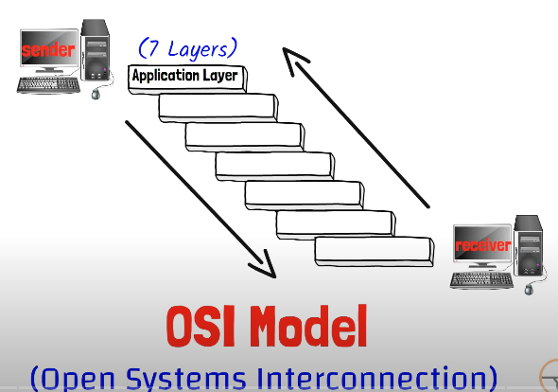

Application Layer
Determine which protocols used in you action and provide it .
By example :
You enter google and write google.com , you will noitice that the brower write before it https , and that is the protocol for surfing the internet
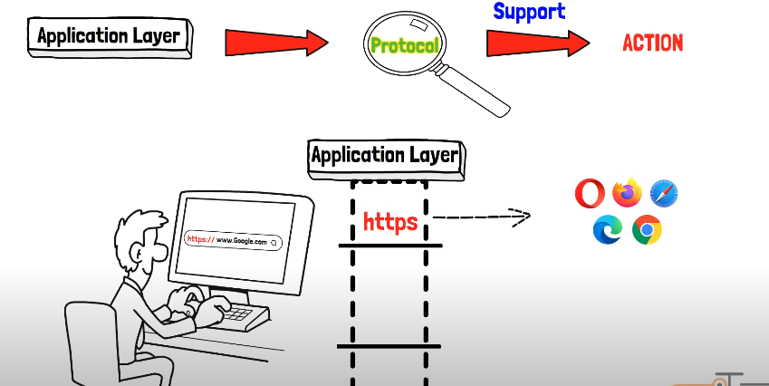

1. Browsing a Website
Action: You enter google.com in your browser.
Protocol: HTTPS (HyperText Transfer Protocol Secure).
What Happens:
- The browser adds https:// before the address (e.g., https://google.com).
- HTTPS ensures the connection is encrypted and secure.
Why It Matters:
- Protects your data (e.g., passwords, credit card info) from hackers.
Layer 7 Role:
- The Application Layer provides HTTPS as the protocol for secure web browsing.

2. Transferring Files
Action: You upload a file to a server using an FTP client.
Protocol: FTP (File Transfer Protocol).
What Happens:
- The client connects to the server using ftp:// (e.g., ftp://example.com).
- FTP transfers the file in its original format.
Why It Matters:
- Ideal for sharing large files (e.g., videos, backups) between devices.
Layer 7 Role:
- The Application Layer provides FTP as the protocol for file transfers.
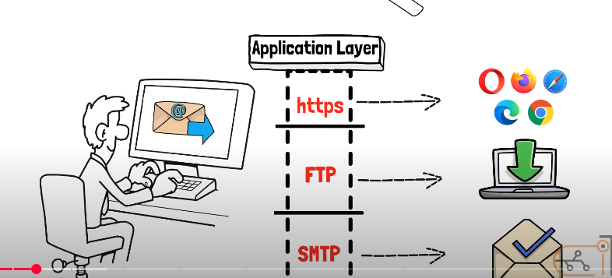

Presentation layer
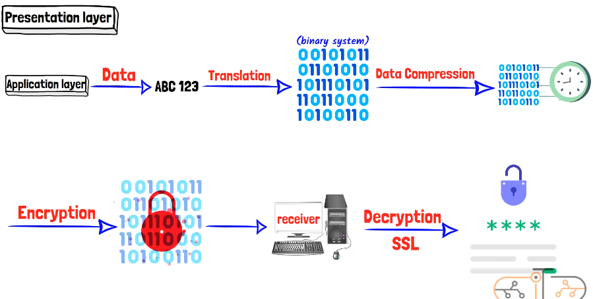

The Presentation Layer takes the data coming from the Application Layer, which is in human-readable formats (characters, images, numbers, etc.), and converts it into machine language (binary: 0s and 1s). This process is called translation. After translation, it reduces the number of binaries through a process called data compression, which shrinks file sizes to make transmission faster and more efficient.

Real-Life Example
Imagine you’re sending a 10MB photo to a friend on WhatsApp:
- Translation: The photo is converted into binary (0s and 1s).
- Compression: The binary data is shrunk to 2MB for faster sending.
- Result: Your friend receives the photo almost instantly, even on a slow connection.
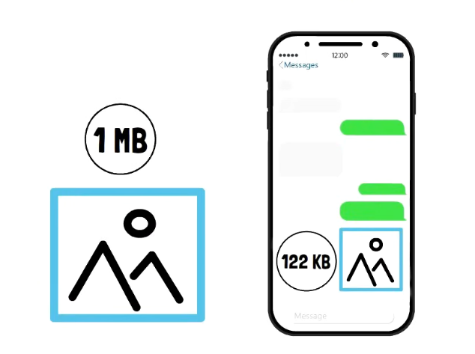

Additionally, the Presentation Layer encrypts the data before sending it, and the receiver decrypts it using protocols like SSL/TLS.

Key Takeaway
The Presentation Layer is the unsung hero البطل المجهول of networking. Every time you send a file, stream a video, or log into a secure website, it’s working silently to ensure your data is readable, secure, and efficient. Without it, the internet would be a chaotic mess of incompatible formats, slow transfers, and vulnerable data! 🌐

Summary of the Presentation Layer
The Presentation Layer (Layer 6) performs three critical functions to ensure data is ready for transmission:
- Translation: Converts human-readable data (text, images, numbers) into machine-readable binary (0s and 1s).
- Compression: Reduces the size of data to make transmission faster and more efficient.
- Encryption: Secures data by encrypting it before sending, and the receiver decrypts it using protocols like SSL/TLS.

Why It’s Important
- Translation ensures data is understood by different systems.
- Compression saves bandwidth and speeds up transfers.
- Encryption protects sensitive information from being intercepted.

Session layer

